IOT BASED AIR POLLUTION MONITORING SYSTEM

A Project report submitted in partial fulfilment of the requirement for the degree of BE in computer science and Engineering

By

I.HARINI (513221104008)

Under the supervision of professor and HOD Department of computer science and Engineering

PHASE 2 : INNOVATION

*“Sensing technologies are the new eyes and ears for cities to understand air quality, as well as the sources and health risks from pollution. We have a unique opportunity to work with technology innovators, academia, private sector and civil society to connect health and techn* In some parts of the world, a lack of data makes understanding local pollution–and its impact on community health–nearly impossible.

New, lower-cost air pollution sensing technologies can change that. These new sensors are not only more accessible than traditional monitoring methods. They also show how pollution changes from neighborhood to neighborhood, or even block to block.

This kind of hyperlocal data can shine a light on previously invisible hotspots, helping officials and empowering communities to make a stronger case for changes that protect public health and the environment

**

#### Businesses:

Cities can use hyperlocal pollution data to invest in clean transportation, create clean air zones, change land use rules and more efficiently set and enforce pollution and emissions rules.

This expanding field brings not only opportunities for cities and sensing technology, fleet management and data analysis

#### A Growing Market for Pollution Sensors:

Tech entrepreneurs can help cities tackle their air pollution challenges by investing in the growing market for monitoring technology. Until now identifying funding opportunities has been challenging. Learn more about the [report a](https://www.edf.org/Zegh?ut_sid=a0aa7133-6871-4468-a6f2-1f42514d35e2&ut_pid=118c6323-1b4d-4d3d-8500-7f3f3bf2a8b8&_gl=1*o1szkp*_ga*MzQwNTMzNTQ1LjE2OTY5MjYwODk.*_ga_JFHPM2052Z*MTY5NjkyNzk0Ny4yLjAuMTY5NjkyNzk0Ny4wLjAuMA..)

#### Exploring Investments Across the Globe

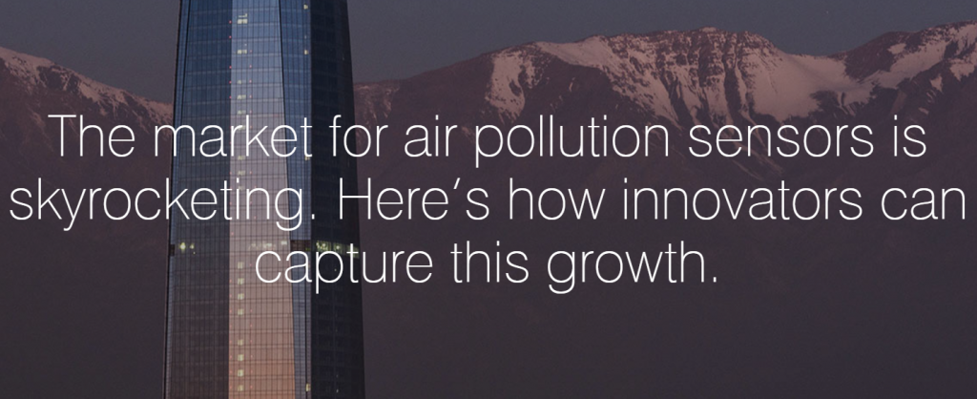 Entrepreneurs and technology innovators can help solve air pollution challenges by investing in the growing market for sensor technologies. [Public investment, private innovation: The global market for air quality monitoring](https://business.edf.org/files/AQ-Landscape_Web.pdf)provides a landscape of regional demand, public funding opportunities and policies for air quality monitoring to guide technology providers exploring and investing in new markets. The report focuses on five regions: the United States and Canada, the European Union, Latin America, India, and China.